RECREATIONAL ADVENTURE COMPANY 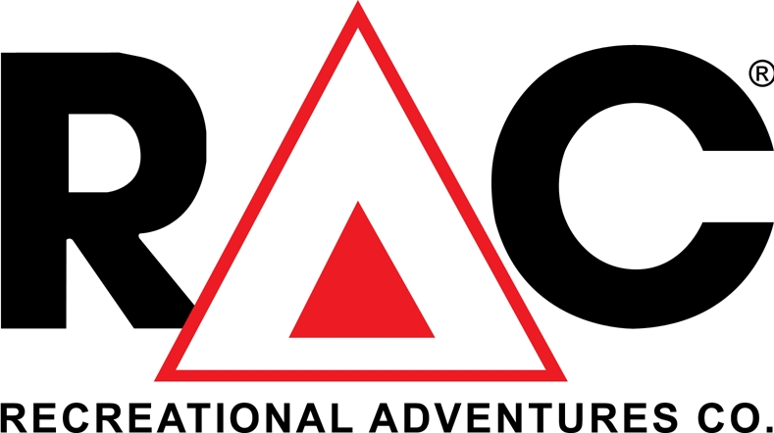

FOR IMMEDIATE RELEASE
MARCH 14, 2016

CONTACT:
Mike Atkinson
General Manager
Mount Rushmore KOA at Palmer Gulch
800-562-8503 or matkinson@racpack.com

MOUNT RUSHMORE RESORT AT PALMER GULCH
LAUNCHES 3-RODEO SERIES JUNE 11

The hoots and hollers of Wild West rodeo action will echo around Palmer Gulch starting Saturday, June 11, at 6:30 p.m., when the first of three rodeos kicks off at the Mount Rushmore Resort at Palmer Gulch.

The Mount Rushmore Rodeo at Palmer Gulch continues Sunday, July 10, at 6:30 p.m. and Saturday, Aug. 20 at 6 p.m. Activities for rodeo fans are planned before each rodeo and they’ll be dancing to a live band after the rodeo competition concludes each evening.

The Mount Rushmore Resort at Palmer Gulch is home to Mount Rushmore Lodge and Mount Rushmore KOA. It is a popular vacation destination for thousands of travelers every year looking to enjoy the resort’s many facilities and its beautiful location in South Dakota’s Black Hill’s -- just minutes away from Mount Rushmore National Memorial.

This is the first rodeo series presented by the resort, and officials expect that visitors to the area and locals looking for entertainment in the great outdoors will enjoy the events.

“We can’t wait for our first rodeo date,” said Mike Atkinson, General Manager at Mount Rushmore KOA. “Palmer Gulch is the perfect place for cowboys, cowgirls and rodeo fans to participate in this truly Western experience.”

“We’re delighted to launch our first rodeos this season for our guests and other visitors to the Black Hills,” he said.

Produced by LKC Rodeo Productions, the rodeo events include bull riding, saddle bronc, bareback, team roping, barrel racing and mutton bustin’ fun for the kids. LKC Rodeo Productions, of Huntley, Montana, is a family-owned and operated company. It has produced rodeos in communities across the Pacific Northwest and Rocky Mountain region since 2009.

Again, the dates for the first season of the Mount Rushmore Rodeo at Palmer Gulch:
Saturday, June 11 at 6:30 p.m.
Sunday, July 10 at 6:30 p.m.
Saturday, Aug. 20 at 6 p.m.

END

For more on Mount Rushmore Resort at Palmer Gulch, go to www.palmergulch.com
For more on LKC Rodeo Productions, go to www.lkcrodeo.com

