Two family friendly Halloween weekends
Friday and Saturday- Oct 17th & 18th
and
Friday and Saturday- Oct 24th & 25th
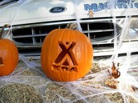

More information
phone #1-706-657-6815 or 1-800-562-1239

KOA staff directed-Activity List
Friday October 17th
7:30pm Movie - ParaNorman- Rated PG
Saturday October 18th
12:00pm -Tie dye T-shirts
3:00pm - Egg Toss
4:30pm - Scarecrow decorating contest-judging
5:15pm - Costume decorating contest-judging
6:15pm - Site decorating contest-judging
6:30pm - Trick or treating starts
7:00-10:00pm - Haunted forest
7:30pm - Movie - Wallace & Gromit-Curse of the Were-Rabbitt- Rated G

Friday October 24th
7:30pm Movie - Monster House- Rated PG
Saturday October 25th
12:00pm -Tie dye T-shirts
3:00pm - Egg Toss
4:30pm - Scarecrow decorating contest-judging
5:15pm - Costume decorating contest-judging
6:15pm - Site decorating contest-judging
6:30pm - Trick or treating starts
7:00 - 10:00pm - Haunted forest
7:30pm - Movie - Hotel Transylvania- Rated PG
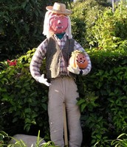 | 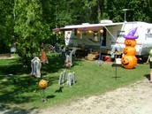
Join the scarecrow decorating contest  Make anything that involves a scarecrow and try to win KOA $20.00 cash gift card | Create a haunted campsite  First place winners receive $50.00 and second place winners receive $25.00 | Adult and children costume contests  Adults can win $50.00 for first place and $25.00 for second place.  Children win grab bags loaded with toys and candy for first and second place winners

