KOA Select My Site

This is a new feature we are excited to introduce this season which has been a huge success at other KOAs. It’s the ability for guests to pick and reserve a specific site #, which is something we receive requests for all the time. This option can be done online at ErieKOA.com and on the KOA app through your electronic devices. This feature also provides guests who are camping/traveling together to have the opportunity to have multiple sites together, lock in the sites that they prefer, and it will be guaranteed. There is a one-time $20 nonrefundable fee per site to lock it in. VIPs are also subject to this cancellation fee as it is optional to use the “KOA Select My Site” feature and is nonrefundable to all guests. This fee will be added to the payment screen at check-out if it is used.

As always, if the guest chooses not to use this feature, they still are guaranteed the specific site type they reserved, just not a certain site # or they may not be next to their group. We will do our best to accommodate your site requests, but this will be the only way to guarantee it. The campground reserves the right without notice to change site #s within the site type that was chosen. Final site #s will be assigned at check-in and are subject to change at any time until then.

Instructions
Here are some instructions to help you with your selection.
- Please enter your reservation site selections at www.ErieKOA.com.
- On the Choose Your Campsite screen click on the “KOA Select My Site (+$20.00)” below the “Reserve” link to see what sites are available to reserve under the site group.
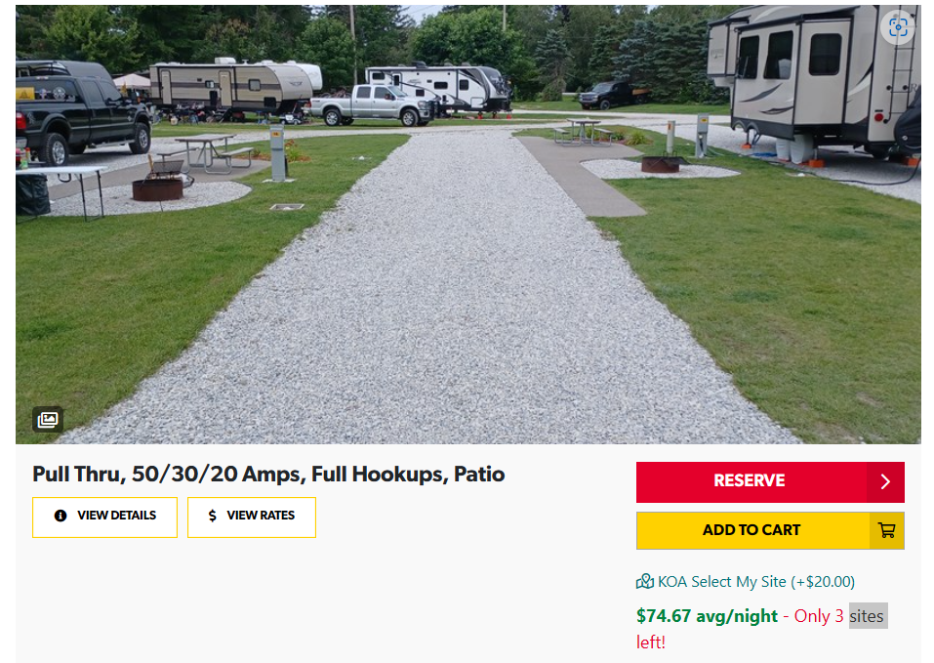

- Select My Site from the drop-down list, then select “Continue”. The sites in the drop-down list are the sites that are available under the site group you had selected. i.e., Pull Thru, 50/30/20 Amps, Full Hookups, Patio.

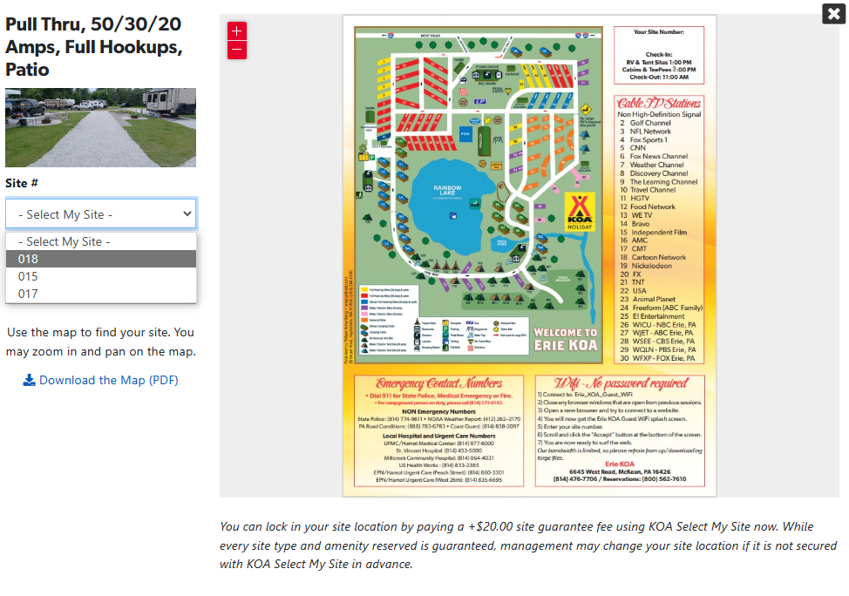

- Once you are on the payment screen, you’ll see that the $20 nonrefundable “KOA Select My Site” fee was added and the site # you had selected from the drop-down list.

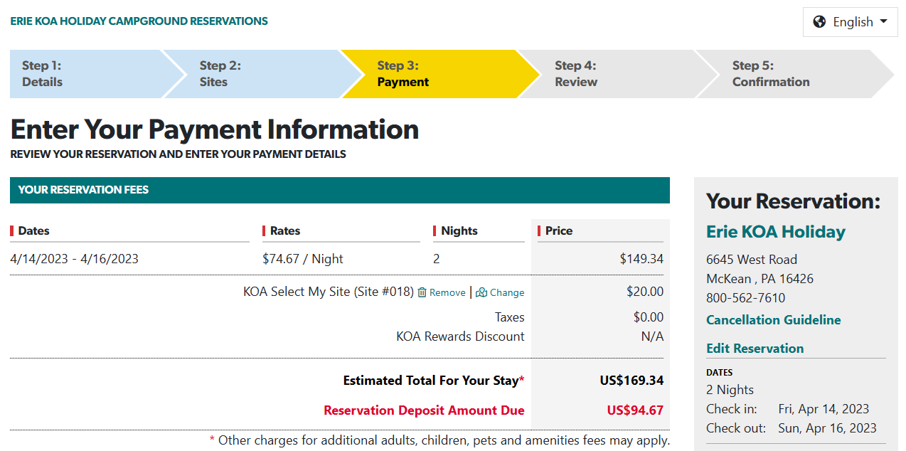

- If you are not happy with your selection you can either click on the “Remove” to delete your site selection or if you would like to select a different site within that group, you can click on the “Change” and then make another selection.

- If you would like to reserve a specific site # that was not available in the “KOA Select My Site” drop-down list, you can add a request that includes that site # in the “Special Request Box” on your reservation and we can lock it in for you if it is available or becomes available. i.e. below

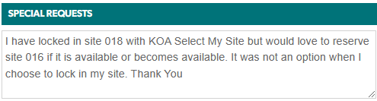

- If you are using this option and there is a site # you would like to reserve and it isn’t available in the drop-down list, there is a chance that it still may be available. You can put in the reservation “Special Request” the site # you would like to lock in and give us permission to charge the $20 nonrefundable lock fee. If the site is available or becomes available, we’ll lock it in for you.

- For groups wanting to be next with each other, when making your reservations, you can now coordinate your site types and choose sites next to each other from the drop-down list.

- We hope you find this enhancement to be a beneficial and user friendly. If you are having difficulties, you can, always put in the “Special Request” to let us know that you would like us to lock it in for you and charge the $20 nonrefundable fee.

Thank you for planning your stay with us. We look forward to seeing you this upcoming season.

Erie KOA Holiday
McKean, PA

