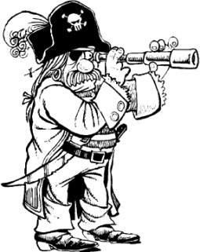
**Saturday August 6th, 10AM sites will open for reservations for 2016 up until August 6th, 2017 **
Pirate Weekend
At Emmett KOA
August 4th-7th

Thursday: 9:00am-8:30pm $Jumping Pillow
10:15-10:45 Arts & Crafts at the Pavilion
11:00-12:00 Bingo at the Pavilion
12:30-1:00 Volleyball meet at the court
1:30-2:00 Sidewalk chalk at the Basketball Court
2:30-3:30 Zoom Floom at the Beach (Slip & Slide- weather permitting)
4:00-4:30 Kickball meet at playground
4:45-5:15 Gaga Ball meet at the Pit
7:00-7:30 Parachute Games at playground

Friday: 9:00am-8:30pm $Jumping Pillow
3:15-4:15 Zoom Floom at the Beach (Slip & Slide- weather permitting)
8:45pm Movie under the stars/ $1 popcorn

Saturday: 9:00am-8:30pm $Jumping Pillow
11:00-12:00 $Bingo at the Pavilion
12:30-1:30 Zoom Floom at the Beach (Slip & Slide- weather permitting)

3:00-3:30 Gold Rush!! Kids don’t miss this! (Near the Playground)
7:00 Wagon Ride Meet Promptly at the Store
8:00-9:00 Magic Show at the Pavilion

Sunday:
9:00am-8:30pm $Jumping Pillow
2:30-3:30 Zoom Floom at the Beach (Slip & Slide- weather permitting)
4:00-4:30 Arts & Crafts at the Pavilion
4:45-5:15 Gaga Ball at the Pit
7:00-? Wagon ride meet promptly in front of the store
8:00-8:30 $Ashby’s ice cream at the Pavilion

Flipper Snack
Bar

(AT THE PAVILION)
Featuring Hunt’s Pizza & Wings &
Ashby’s Ice Cream

Thursday 4pm-9pm
Friday 4pm-9pm
Saturday 12pm-9pm
Sunday 9am-10:30am breakfast &
8pm-8:30pm (Ice Cream)

