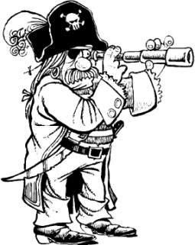
**Saturday August 8th, 10AM sites will open for reservations for 2016 up until August 7th, 2016 with exception of cabins 1-5 for owners family reunion**
Pirate Weekend
At Emmett KOA
August 6th-9th

Thursday: 9:00am-8:30pm $ Jumping Pillow
3:15-3:45 Arts & Crafts at the Pavilion
4:00-5:00 Bingo at the Pavilion
4:00-9:00 $Flipper Snack Bar$
5:15-5:45 Scavenger Hunt meet at the Pavilion
7:00-8:00 Karaoke at the Pavilion
Flipper Snack
Bar

Friday: 9:00am-8:30pm $Jumping Pillow
8:45pm Movie under the stars/ $1 popcorn

Saturday: 9:00am-9:00pm $Jumping Pillow
12:00-12:30 Cannon Ball Toss (wear your bathing suit)
2:00-2:45 Gold Rush!! Kids don’t miss this! (Near the Playground)
3:30-4:30 $Bingo at the Pavilion
7:00 Wagon Ride Meet Promptly at the Store
8:00-9:00 Magic Show at the Pavilion

Sunday: 9:00-10:30 $ Breakfast at the Pavilion Adults $6/ Children 10-6 $4 Children 5-under $2
9:00am-8:30pm $Jumping Pillow
7:00 Wagon Ride meet at the Store
8:00-8:30 $Ashby’s Ice Cream Social at the Snack Bar

(AT THE PAVILION)
Featuring Hunt’s Pizza & Wings &
Ashby’s Ice Cream
Thursday 4pm-9pm
Friday 4pm-9pm
Saturday 12pm-9pm
Sunday 8pm-9pm (Ice Cream)

