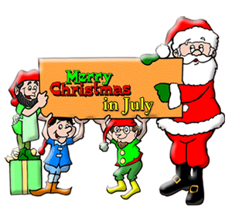
**Saturday July 22 10 AM sites will open for reservations for 2017 up until July 23, 2017**
At Emmett KOA
7/21-7/23
Thursday:
9:00-8:30pm $Jumping Pillow
10:00-10:30 Kickball meet at playground
10:45-11:45 Bingo at the Pavilion
12:00-12:30 Arts & Crafts at the Pavilion
1:00-2:00 Zoom Floom at the Beach (Slip & Slide- weather permitting)
4:00-9:00pm $Ashby’s Ice Cream/ Hunt’s Pizza & Wings at the Pavilion

Friday: 9:00am-8:30pm $Jumping Pillow
4:00-9:00pm $Ashby’s Ice Cream/ Hunt’s Pizza & Wings at the Pavilion
Flipper Snack Bar
7:00-8:00 Game show trivia at the Pavilion
8:30pm-Movie at the Pavilion/ $1 popcorn

Saturday:
9:00am-8:30pm $Jumping Pillow
10:00-10:30 Christmas Arts & Crafts Decorate Cookies at the Pavilion
12:00-1:30 Zoom Floom at the Beach (Slip & Slide- weather permitting)
1:30-2:00 Snowball Toss at the Playground
2:00-2:30 SNOW PARTY at the Playground (Wear your bathing suit!)

3:00-4:00 $1 Bingo at the Pavilion
7:00 Wagon ride with Santa meet in front of the store
7:30-? Pictures with Santa at the Pavilion

Sunday:
9:00-10:30 BREAKFAST AT THE PAVILION ALL YOU CAN EAT BUFFET $6 adults/ $4 children 10-under
9:00am-8:30pm $Jumping Pillow
2:30-3:30 Zoom Floom at the Beach (Slip & Slide- weather permitting)
4:00-4:30 Arts & Crafts at the Pavilion
4:45-5:15 Gaga Ball at the Pit
7:00-? Wagon ride meet promptly in front of the store
8:00-8:30 $Ashby’s ice cream at the Pavilion

(AT THE PAVILION)
Thursday 4pm-9pm
Friday 4pm-9pm
Saturday 12pm-9pm
Sunday 9am-10:30am breakfast &
8pm-8:30pm (ice cream only)

*Hunt’s Pizza, Hunt’s Wings & Ashby’s Ice Cream*

