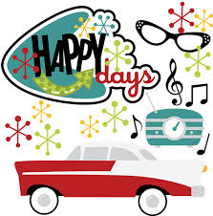
50’s Weekend
At Emmett KOA
August 17-20

Thursday: 9:00-8:30pm $Jumping Pillow
2:15-2:45Arts & Crafts at the Pavilion
3:00-3:30 Scavenger Hunt meet at the Pavilion
4:00-5:00 Bingo at the Pavilion
7:00-7:30 Parachute games near the playground

Friday: 9:00am-8:30pm $Jumping Pillow
10:30am Barrel Train ride meet outside the store
8:45pm Movie under the stars/ $1 popcorn

Saturday: 9:00am-8:30pm $Jumping Pillow
10:30am-? Barrel Train ride meet outside the store
2:00-2:30 Color an Emmett KOA bag or backpack $6 at the pavilion
3:30-4:00 Bubble Gum Bubble Contest near Playground
4:00-5:00 $1 Bingo at the Pavilion
6:30 Wagon Ride Meet Promptly at the Store
7:00-10:00 DJ Dance Party at the Pavilion
7:15-7:45 Hula Hoop Contest at the Pavilion

Sunday:
9:00am-8:30pm $Jumping Pillow
7:00 Barrel Train ride meet outside the store
8:00-8:30 $Ashby’s Ice Cream at the Pavilion
Flipper Snack
Bar

Featuring Hunt’s Pizza & Wings &
Ashby’s Ice Cream
Thursday 4pm-9pm
Friday 4pm-9pm
Saturday 12pm-9pm
Sunday 8pm-8:30 (Ice Cream)
**Saturday August 19th, 10AM sites will open for reservations for 2018 up until August 19th, 2018 **

