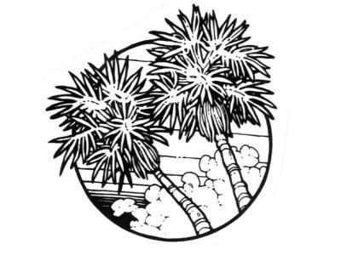
**Saturday July 11^{h} 10 AM sites will open for reservations for 2016 up until July 10, 2016**
Beach Party Weekend
At Emmett KOA
July 9-12

Thursday: 9:00am-8:30pm $Jumping Pillow
2:15-2:45 Arts & Crafts at the Pavilion
3:00-4:00 $1 Bingo at the Pavilion
4:30-5:00 Volleyball meet at the Court
5:00-9:00 Flipper Snack Bar Open
5:30-? Mini Golf Tournament
7:00-8:00 Karaoke at the Pavilion

Friday: 9:00am-8:30pm-$Jumping Pillow
8:30 Movie at the Pavilion/ $1 Popcorn

Saturday: 9:00am-8:30pm-$Jumping Pillow
10:00-11:00 Sandcastle Contest at the beach
11:30 Sandcastle Contest Awards at the beach
1:00-1:30 ROOT BEER FLOATS AT THE BEACH (wear your bathing suit)
3:00-4:00 $Bingo at the Pavilion
4:30-5:00 Kids Foam Party (wear your bathing suits)
6:30-? Wagon Ride Meet Promptly in front of the store
7:00-10:00 DJ Dance Party at the Pavilion

Sunday:
9:00-10:30 BREAKFAST AT THE PAVILION ALL YOU CAN EAT BUFFET $6 adults/ $4 children 6-10/ $2 children 5-under
9:00am-8:30pm $Jumping Pillow
11:00 Scavenger Hunt meet at the Pavilion
7:00-? Wagon Ride Meet Promptly in front of the store
8:00-8:30 Ashby’s Ice Cream Social at the Pavilion
Flipper Snack Bar

aAt

At the Pavilion
Thursday 5pm-9pm
Friday 4pm-9pm
Saturday 12pm-9pm
Sunday 8pm-8:30pm (ice cream only)

