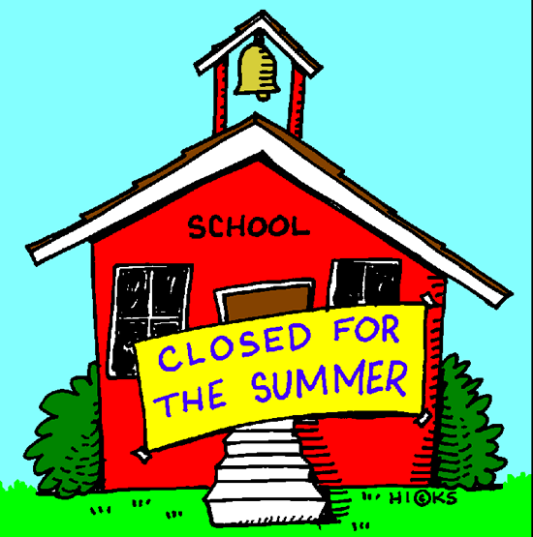

School’s Out Weekend At Emmett KOA
June 5th-7th

Friday:
9:00am-8:30pm $ Jumping Pillow
8:30 Movie at the Pavilion

Saturday: 9:00am-8:30pm? $ Jumping Pillow
10:30-11:00 Arts & Crafts at the Pavilion
11:30-12:00 Kickball near the playground
2:00-3:00 $Bingo at the Pavilion ($1 per card)
7:00 Wagon Ride meet at the Store

Sunday:
9:00am-1:00pm $Jumping Pillow
10:00-? Scavenger Hunt meet at the Pavilion
11:00-11:30 Arts & Crafts at the Pavilion

Flipper Snack Bar
At the Pavilion
Featuring Hunts Pizza/ Wings & Ashby’s Ice Cream
Friday: 5:00pm-9:00pm
Saturday:3:00pm-8:00pm

