September 12th-14th, 2014
VKR Appreciation Weekend!

Activities Include the following:
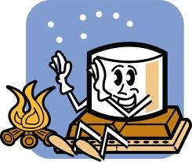
Friday, September 12th:
- Complimentary S’mores 6:30-8pm

Saturday, September 13th:
- VKR Appreciation Lunch 12-2pm by donation (Corn dogs, chips, and a beverage)
- Ice cream Social 3-4 for $1

- Complimentary S’mores 6:30-8
Sunday, September 14th:
- Pancake Breakfast with a healthy serving of pancakes and fresh sausage for $3.50 from 8-10

