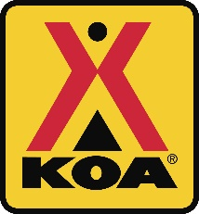 BAY CENTER/WILLAPA BAY 2017 ACTIVITY SCHEDULE

April 7th Easter Weekend
May 12th Care Camp Big Weekend/ Silent Auction /Mothers Day
May 26th Memorial Day Weekend
June 2nd Survival Weekend
June 9th Halloween Weekend
June 16th Fathers Day/Clam Chowder Cookoff
June 23th Pirate Weekend
June 30th Fourth of July/ Campground Picnic
July 7th Fantasy Forest Weekend
July 14th Beach Weekend WEEKEND ACTIVITIES MAY INCLUDE:
July 21 Princess & Super hero Weekend Flashlight Candy Hunt, Root Beer Floats
July 28 Xmas in July Crafts, Games & Campfire Cooking Demo
Aug 4th Cowboys and Robbers Weekend
Aug 11 Chocolate Lovers Weekend
Aug 18th Luau Weekend
Aug 25th Kite Weekend
Sept 1 Labor Day/ Old Time Country Fair

Activities are subject to change without notice
For more details visit KOA.com/bay center

