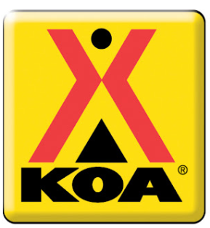
Acton KOA
Family Activities

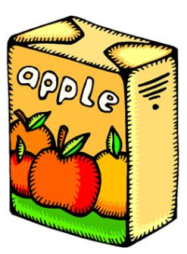
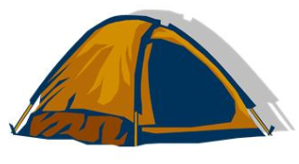
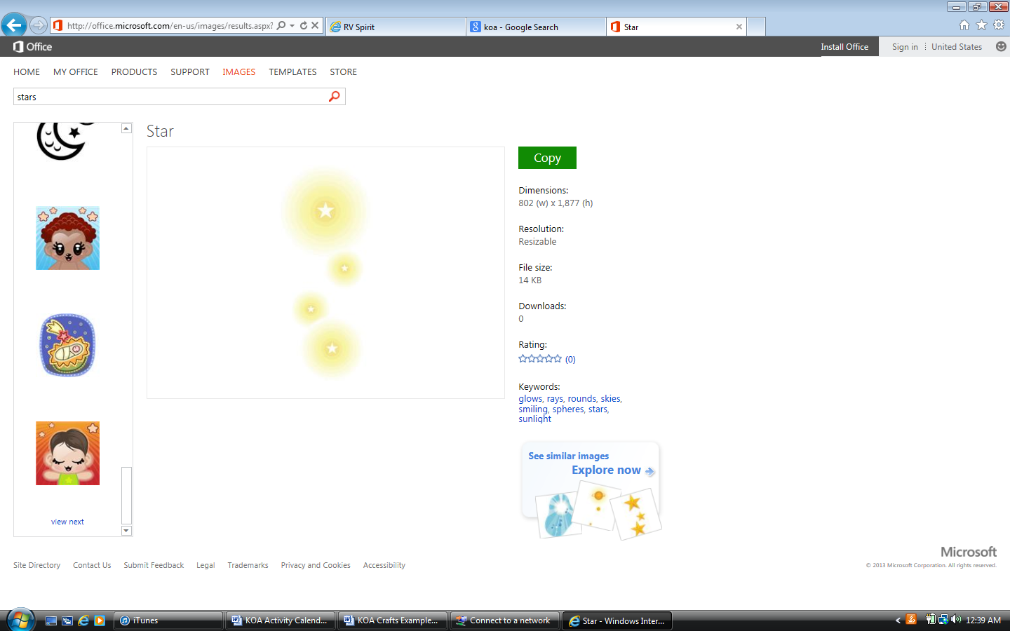
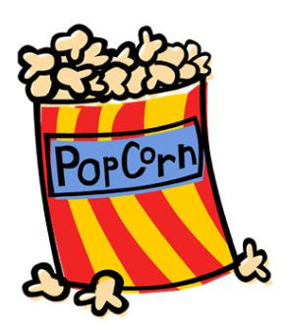
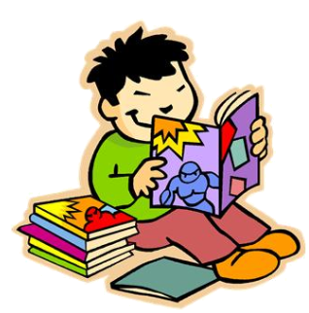

Movie Under the Stars
Bring your blanket & Chairs! Popcorn, Candy & Drinks
will be sold

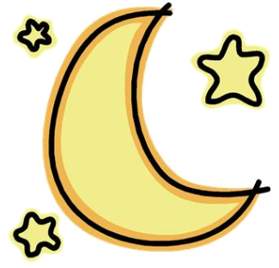
FRIDAY, JULY 12th

● 8:00PM “Movie Under the
Stars” by Playground.

Showing
**Willy Wanka**
SATURDAY, JULY 13TH

● 10 AM Create a “Popsicle
Picture-Frames”
Meet in Rec. Room by office

● 1 PM “Snow Cone Zone”
Golf cart will drive around Park

● 8:00PM “Movie Under the
Stars” by Playground.

Showing
**Coraline**

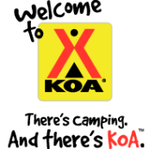
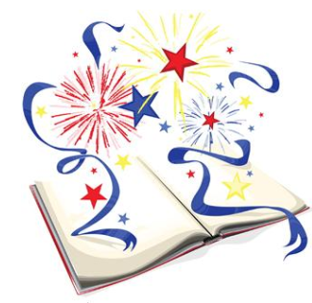

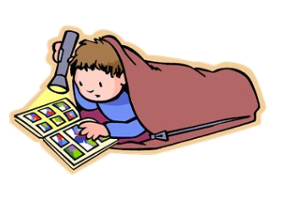

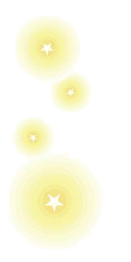
RECREATION ROOM
Parents & kids
are encouraged to come by the *Recreation room to color, read books, borrow Dvd’s or play board games.
Parents please
clean-up after your kids.

*Recreation Room subject
to availability

MOVIE NIGHT’S
Bring your chairs & blankets!
For Sale
Small Popcorn: .50¢
Large Popcorn: $1
Drinks: $1
Candy: $1

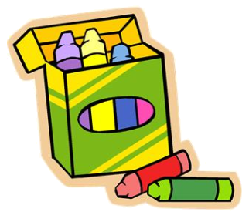

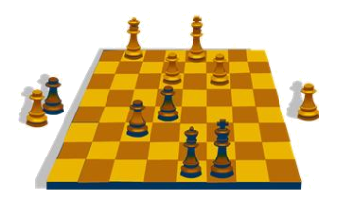
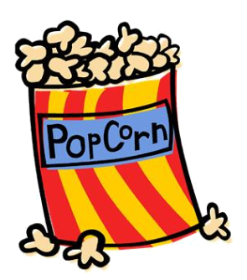
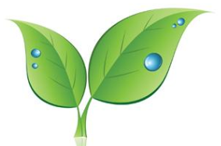
FACILITY HOURS

Pool Hours: 9AM – 9PM
Rec. Rm.:9AM - 5PM

Movie Under the Stars
Bring your blanket & Chairs! Popcorn, Candy & Drinks
will be sold

